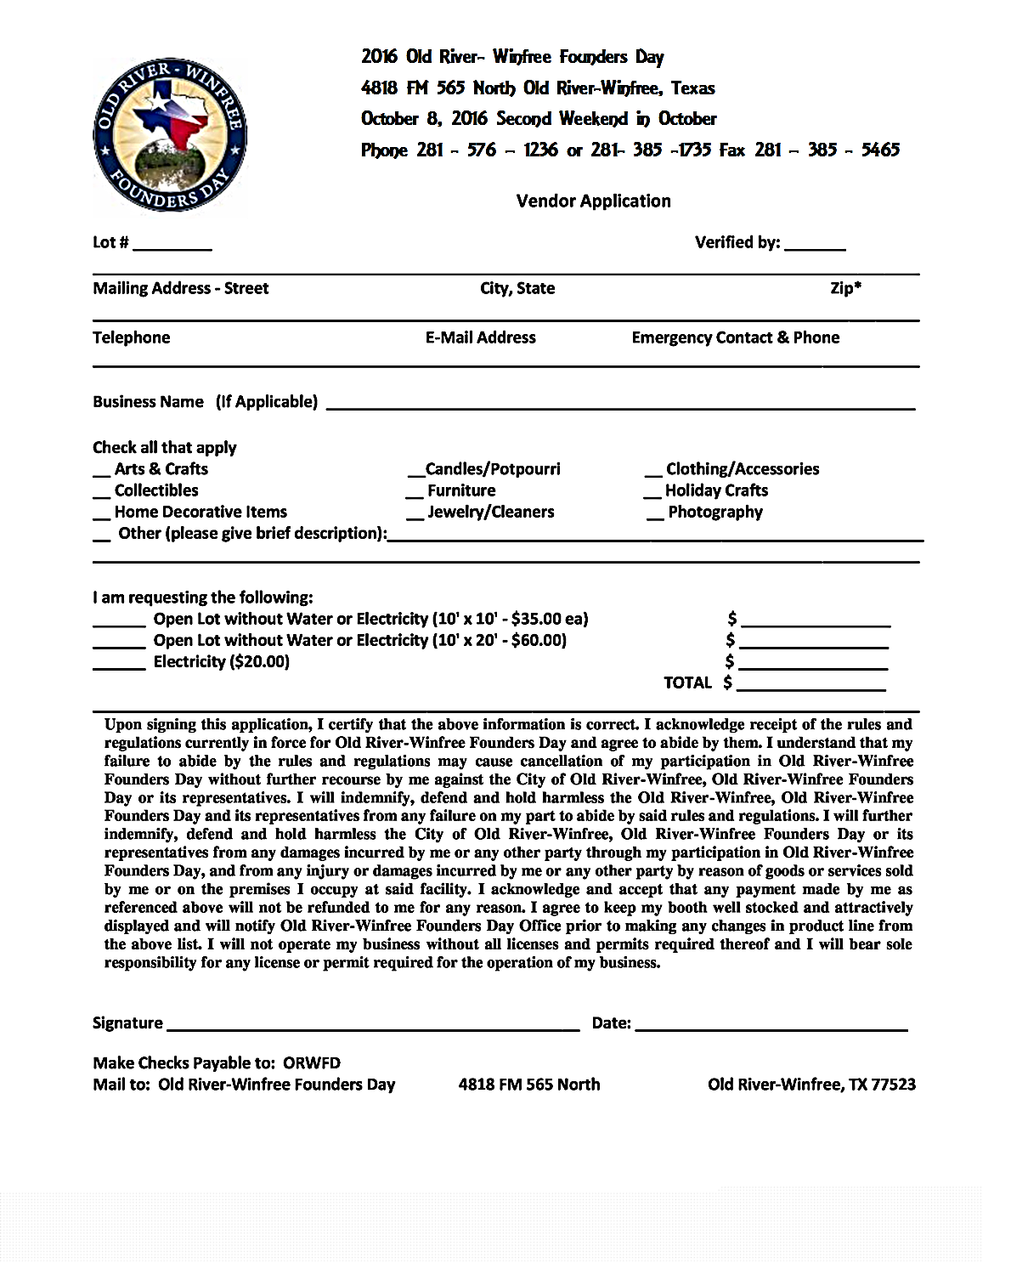

**2017 Old-River Winfree Founder’s Day**

**4818 FM 565 North Old River-Winfree, Texas**

**October 13, 2018 Second Weekend in October**

**Phone : 281-385-1735 Fax: 281-385-5465**